Contents

1 Introduction 1

2 Software 1

2.1 Power BI Desktop (May 20 version) 1

2.2 DAX Studio 1

2.3 Excel 1

# Introduction

The users need to install the software in next section on their PCs for training on Power BI.

# Software

## Power BI Desktop (May 21 version)

1. Go to <https://www.microsoft.com/en-us/download/details.aspx?id=57271>

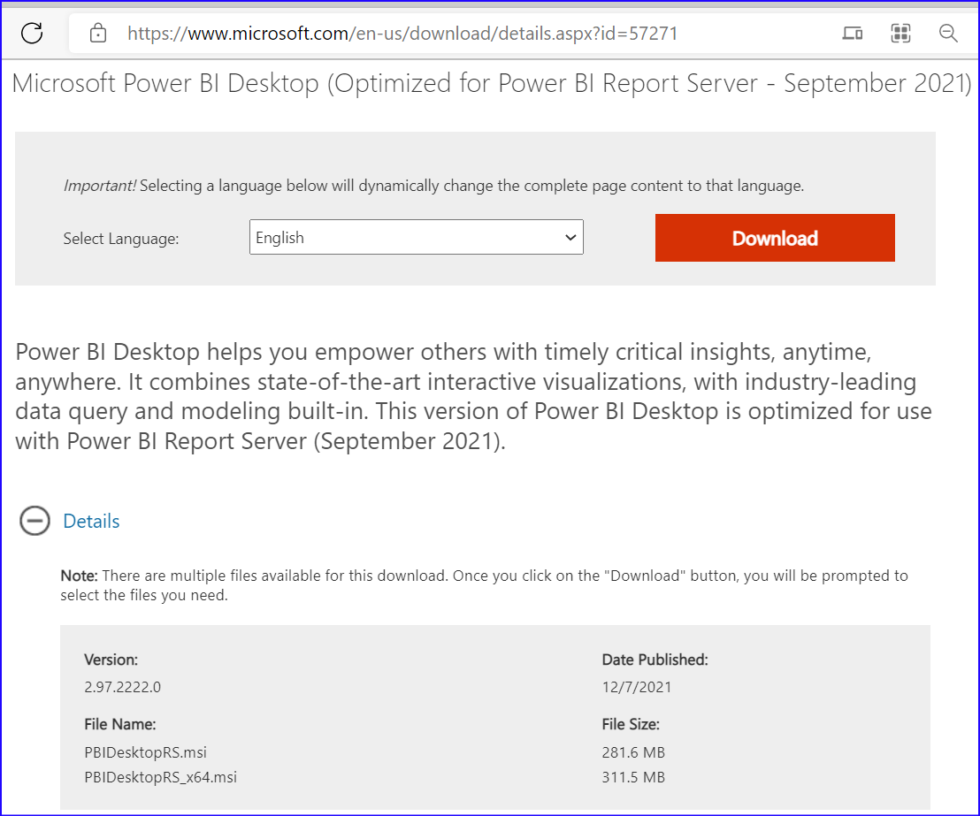

Download and install the same on your machine

* Desktop edition (PBIDesktopRS_x64.msi, if you have 64 bit OS or
* Desktop edition (PBIDesktopRS.msi

## DAX Studio

Download and install DAX Studio from <https://daxstudio.org/downloads/>

## Excel

Excel 2010 or later.